Song: Lloyd Cole and the Commotions “Grace” October, 16th

Once you were an __________
Jesse honey is it hard to __________?
Does it feel so bad to be __________?
you were 23 And you could do __________.
now you open your __________
And spit the gutter __________
I was walking down by the river _____
I decided that I should throw me _____
Because you broke my __________
and you made me __________
In the name of your __________
Still once you were an __________
Did nobody tell __________?
jesse honey oh you look so __________
And old and so very ill at ease these ______
So you tell yourself that you’ll never _____
And you drown your sins in __________
Do you weary so of that bitter _______?
So you spit in my __________
just to keep you __________
Still I can only love __________
I have no option but __________
Is hard to __________?
is it is it hard to swallow? Is ________?
is it hard to take from __________?
Once you were an __________
Did nobody tell __________?
jesse honey is it hard to __________?
Does it feel so bad to be __________?
you were __________
And you could do __________
Now you open your __________
and you spit the gutter __________
Out in the summer __________
You will begin __________
Out in the summer __________
We will begin __________

Once you were an angel
Jesse honey is it hard to take
Does it feel so bad to be 28?
you were 23 And you could do anything.
now you open your mouth
And spit the gutter out
I was walking down by the river Thames
I decided that I should throw me in
Because you broke my heart
and you made me weep
In the name of your sensitivity
Still once you were an angel
Did nobody tell you
jesse honey oh you look so pale
And old and so very ill at ease these days
So you tell yourself that you’ll never win
And you drown your sins in amphetamine
Do you weary so of that bitter taste
So you spit in my face
just to keep you entertained
Still I can only love you
I have no option but to
Is hard to take
is it is it hard to swallow? Is it?
is it hard to take from grace
Once you were an angel
Did nobody tell you
jesse honey is it hard to take
Does it feel so bad to be 28?
you were 23
And you could do anything
Now you open your mouth
and you spit the gutter out
Out in the summer rain
You will begin again
Out in the summer rain
We will begin again

angel out again mouth 28 rain
rain you anything take sensitivity weep
Thames heart angel in take 28
anything mouth out angel taste face
you entertained you pale days to
take it win grace amphetamine

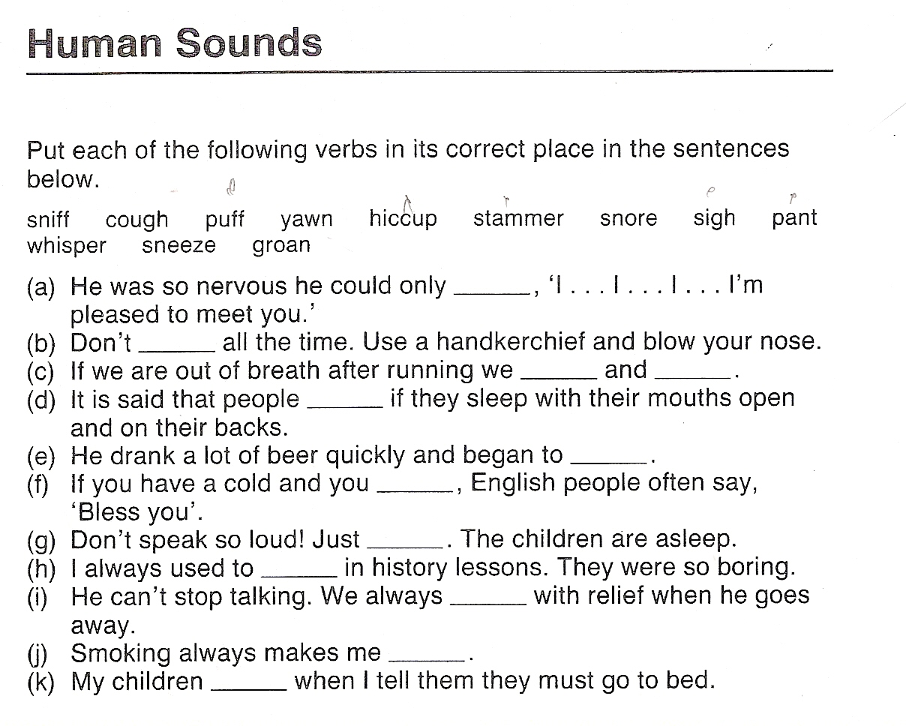

a.- stammer
b.- sniff
c.- puff and pant
d.- snore
e.- hiccup
f.- sneeze
g.- whisper
h.- yawn
i.- sigh
j.- cough
k.- groan

