- How long have I studied for?

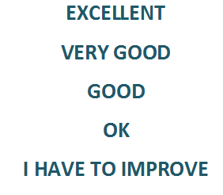1 DAY / 2 DAYS..

1 AFTERNOON...

2 HOURS...

* Where do I have to improve?

READING / WRITING / LISTENING / SPEAKING

- What am I going to do to improve?

READ ENGLISH BOOKS. / SPEAK MORE IN ENGLISH. / ASK THE DOUBTS IN CLASS. / STUDY MORE.

LISTEN SONGS IN ENGLISH. / WATCH ENGLISH VIDEOS...