Cartoon: Copenhagen Tsunami
Wonderful cartoon by Chris Riddel from The Observer presenting the Copenhagen conference 2009. Look at the cartoon and try to answer the following questions:
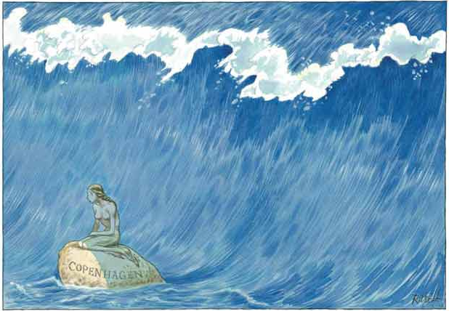
• What is the cartoonist saying to us?
• What's the connection between the tidal wave and climate change?
• The tidal wave can be seen as a metaphor. For what?
• What about the mermaid?
• Is climate change man-made? Are you a warmist or sceptic?
• What do you know about the Copenhagen summit?
• Are you optimistic or pessimistic about chances of solving global warming? Why?

